Implementation of an Apache Webserver
Dustin Phou
Computer Engineering Department, College of Engineering
San Jose State University, San Jose, CA 94303
E-mail: dustinphou@gmail.com

Abstract
The goal of this project was to implement an Apache webserver on a laptop and wirelessly broadcast a webpage to other devices via a router. This will be used in the future to provide a means to send control signals to the bicycle remotely. The implementation of the server and webpage were completed successfully.

1. Introduction
An Apache HTML webserver allows for a device such as a laptop to locally host a webpage. This allows for devices connected to the same network to access and interact with this webpage without having to route communications over the internet. This system is put into place as an addition to the electric bicycle’s other control systems in order to allow for the user to send control inputs, such as a stop signal, to the bicycle remotely through a smartphone. To accomplish this, the webpage must be designed and implemented on a host machine, in this case running in a Linux environment. The host is then connected to a router and devices on the network are given access to the page.

2. Methodology
This section will detail what the goals of this project were and how these goals will be addressed.

2.1. Objectives and Technical Challenges
The main objective was to broadcast a basic HTML webpage to other devices using a router. The webpage should be accessible from other devices using the IP address of the host device. The webpage should be designed to include a few basic functions, such as navigation between pages and loading images.

2.2. Problem Formulation and Design
The problem in this project consisted mainly of getting the server running and gaining access to it on a different device.
- Install and run the Apache web server on a host machine. The host will be running Linux, since the operating system natively supports Apache implementations.
- Create basic webpages using HTML and Javascript. These pages will be used in the future for more complex functions.
- Access the server wirelessly from another device. This will involve using a router and giving access to a local resource over a network.

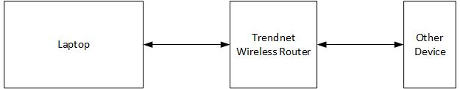

Figure 1. Block Diagram of Overall System

3. Implementation
This section will describe what hardware and software components were used to implement the web server.

3.1. Hardware Design
The following is a list of devices used to implement the server. How these were interfaced can be seen in Figure 1.
Table 1. Bill of Materials
Item # | Description | Notes
1 | Laptop | Running Linux
2 | TEW-432BRP | Wireless Router
3 | Smartphone | Android

3.2. Software Design
The Apache environment was installed onto the Linux host using the command line. The server daemon was immediately up and running after installation, so there was very little to be done in regards to setting up the server.
A relatively basic webpage was created to test if the server was accessible. The webpage uses HTML and JavaScript; however the implementation for this project was simple enough that no JavaScript was necessary. A .js file was included for future inplementations. A basic outline of the webpage’s structure is below:
- Connect to the host server using its IP address
- Display the SJSU logo on the main page
- The main page should have three buttons used to navigate to other pages
- Each page has a back button to return to the home page

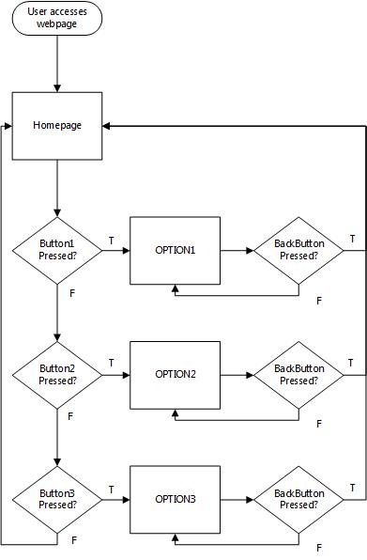
Figure 2. Diagram of website
The pseudocode is as follows:
<HTML>
<BODY>
<p>
Display image of SJSU logo
Welcome to the CMPE 195A Spring 2016 Self-Balancing Bike group's homepage
<br>
Display button b1 that is hyperlinked to option1.html
<br>
Display button b2 that is hyperlinked to option2.html
<br>
Display button b3 that is hyperlinked to option3.html
<script src="scripts.js"></script>
</p>
</BODY>
</HTML>

4. Testing and Verification
To test if the server was running correctly, the computer the server was running needed to be connected to a wireless network via a router. Another device, in this case a phone, was then used to access the webpage remotely. The local IP address of the webhost was entered into the web browser’s address bar to verify that the server was remotely accessible and that navigation between pages was possible. The tests were successful and a screenshot of the webpage can be seen below.


Figure 3. Screenshot of webpage on phone

5. Conclusion
Through the completion of this project, an Apache webserver was successfully created and hosted for other devices in a wireless network to connect to. The server was able to host a basic HTML/Javascript webpage which a remote device was able to visit and interact with. By implementing this server, there are now opportunities to manipulate data values on the host from a remote device. This will allow for implementation of software that will be able to remotely control the self-balancing bicycle.

6. Acknowledgement
Dr. Harry Li provided the basis of the project and idea to implement JavaScript. Jun Ming Liu provided the router used for the wireless component.

7. References
[1] w3schools (n.d.) HTML Tutorial Retrieved from http://www.w3schools.com/html/
[2] w3schools (n.d.) JavaScript Tutorial Retrieved from http://www.w3schools.com/js/
[3] Dreller, J. (2015, June 27) Getting started with Linux Mint for Web Development Retrieved from: http://4digits.net/blog/linux/getting-started-with-linux-mint-for-web-development.html

8. Appendix
Source Code:
index.html:
<!DOCTYPE html>
<HTML>
<HEAD>
<TITLE>
Self-Balancing Bike
</TITLE>
</HEAD>
<BODY>
<p>
<img src="sjsu-logo1.png" style="width:280px;height:280px;"><br><br>
Welcome to the CMPE 195A Spring 2016 Self-Balancing Bike group's homepage
<br>
<a href="option1.html"><button id = "b1" type ="button" >Option 1</button></a>
<br>
<a href="option2.html"><button id = "b2" type ="button" >Option 2</button></a>
<br>
<a href="option3.html"><button id = "b3" type ="button" >Option 3</button></a>
<script src="scripts.js"></script>
</p>
</BODY>
</HTML>

option1.html:
<!DOCTYPE html>
<HTML>
<HEAD>
<TITLE>
OPTION 1
</TITLE>
</HEAD>
<BODY>
<p>
OPTION 1<br><br>
<a href="index.html"><button type ="button" >BACK</button></a>
</p>
</BODY>
</HTML>

option2.html:
<!DOCTYPE html>
<HTML>
<HEAD>
<TITLE>
OPTION 2
</TITLE>
</HEAD>
<BODY>
<p>
OPTION 2<br><br>
<a href="index.html"><button type ="button" >BACK</button></a>
</p>
</BODY>
</HTML>

option3.html:
<!DOCTYPE html>
<HTML>
<HEAD>
<TITLE>
OPTION 3
</TITLE>
</HEAD>
<BODY>
<p>
OPTION 3<br><br>
<a href="index.html"><button type ="button" >BACK</button></a>
</p>
</BODY>
</HTML>

scripts.js:
//for future implementations

